**T1 - Repair in tension**

Undamaged:

* Pieces 2, 3, 4, and 6: Broke suddenly; vertical break at loading point
* Pieces 1 and 5: Gradually tore apart at middle; no full break - press reached max distance first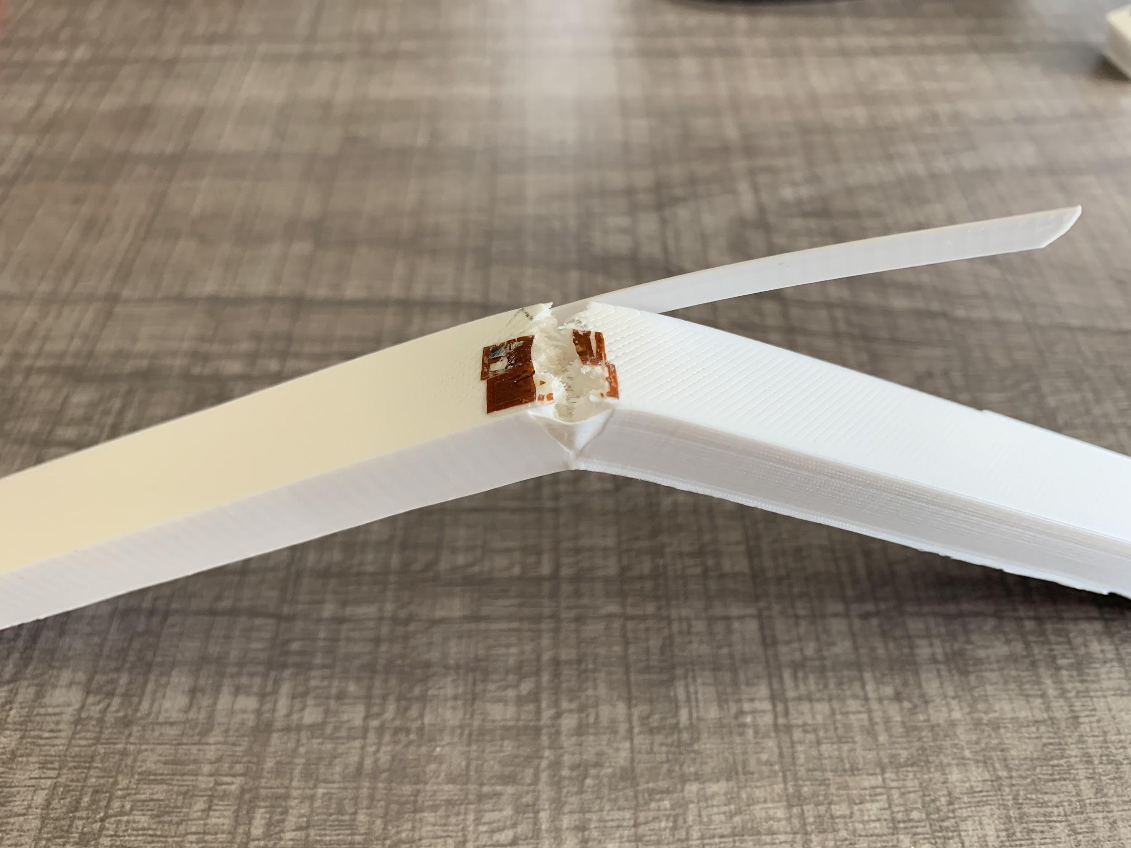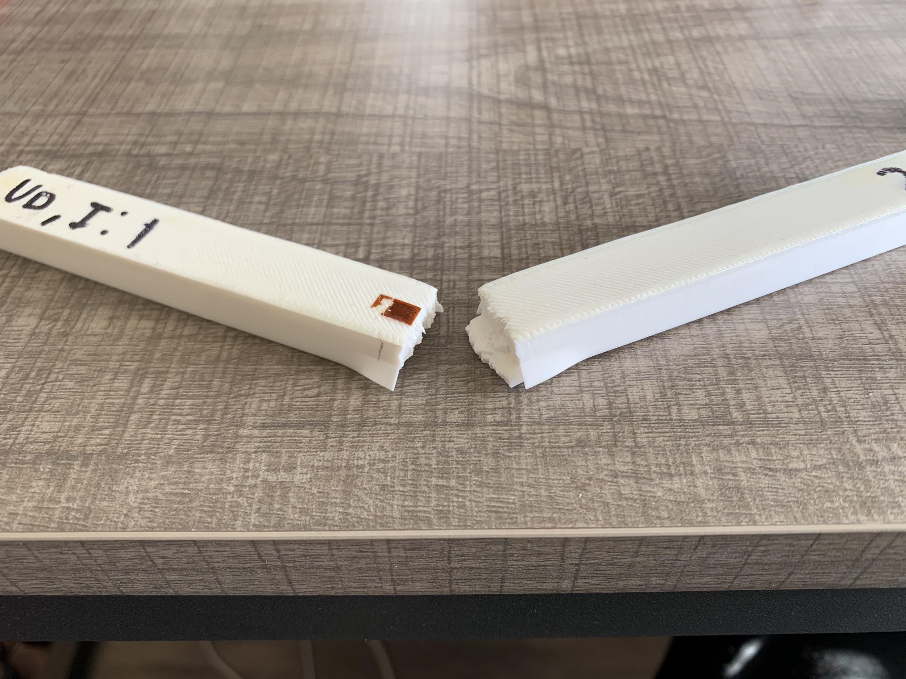

Damaged:

* Pieces 2-6: Gradually tore apart at thinnest point; no full break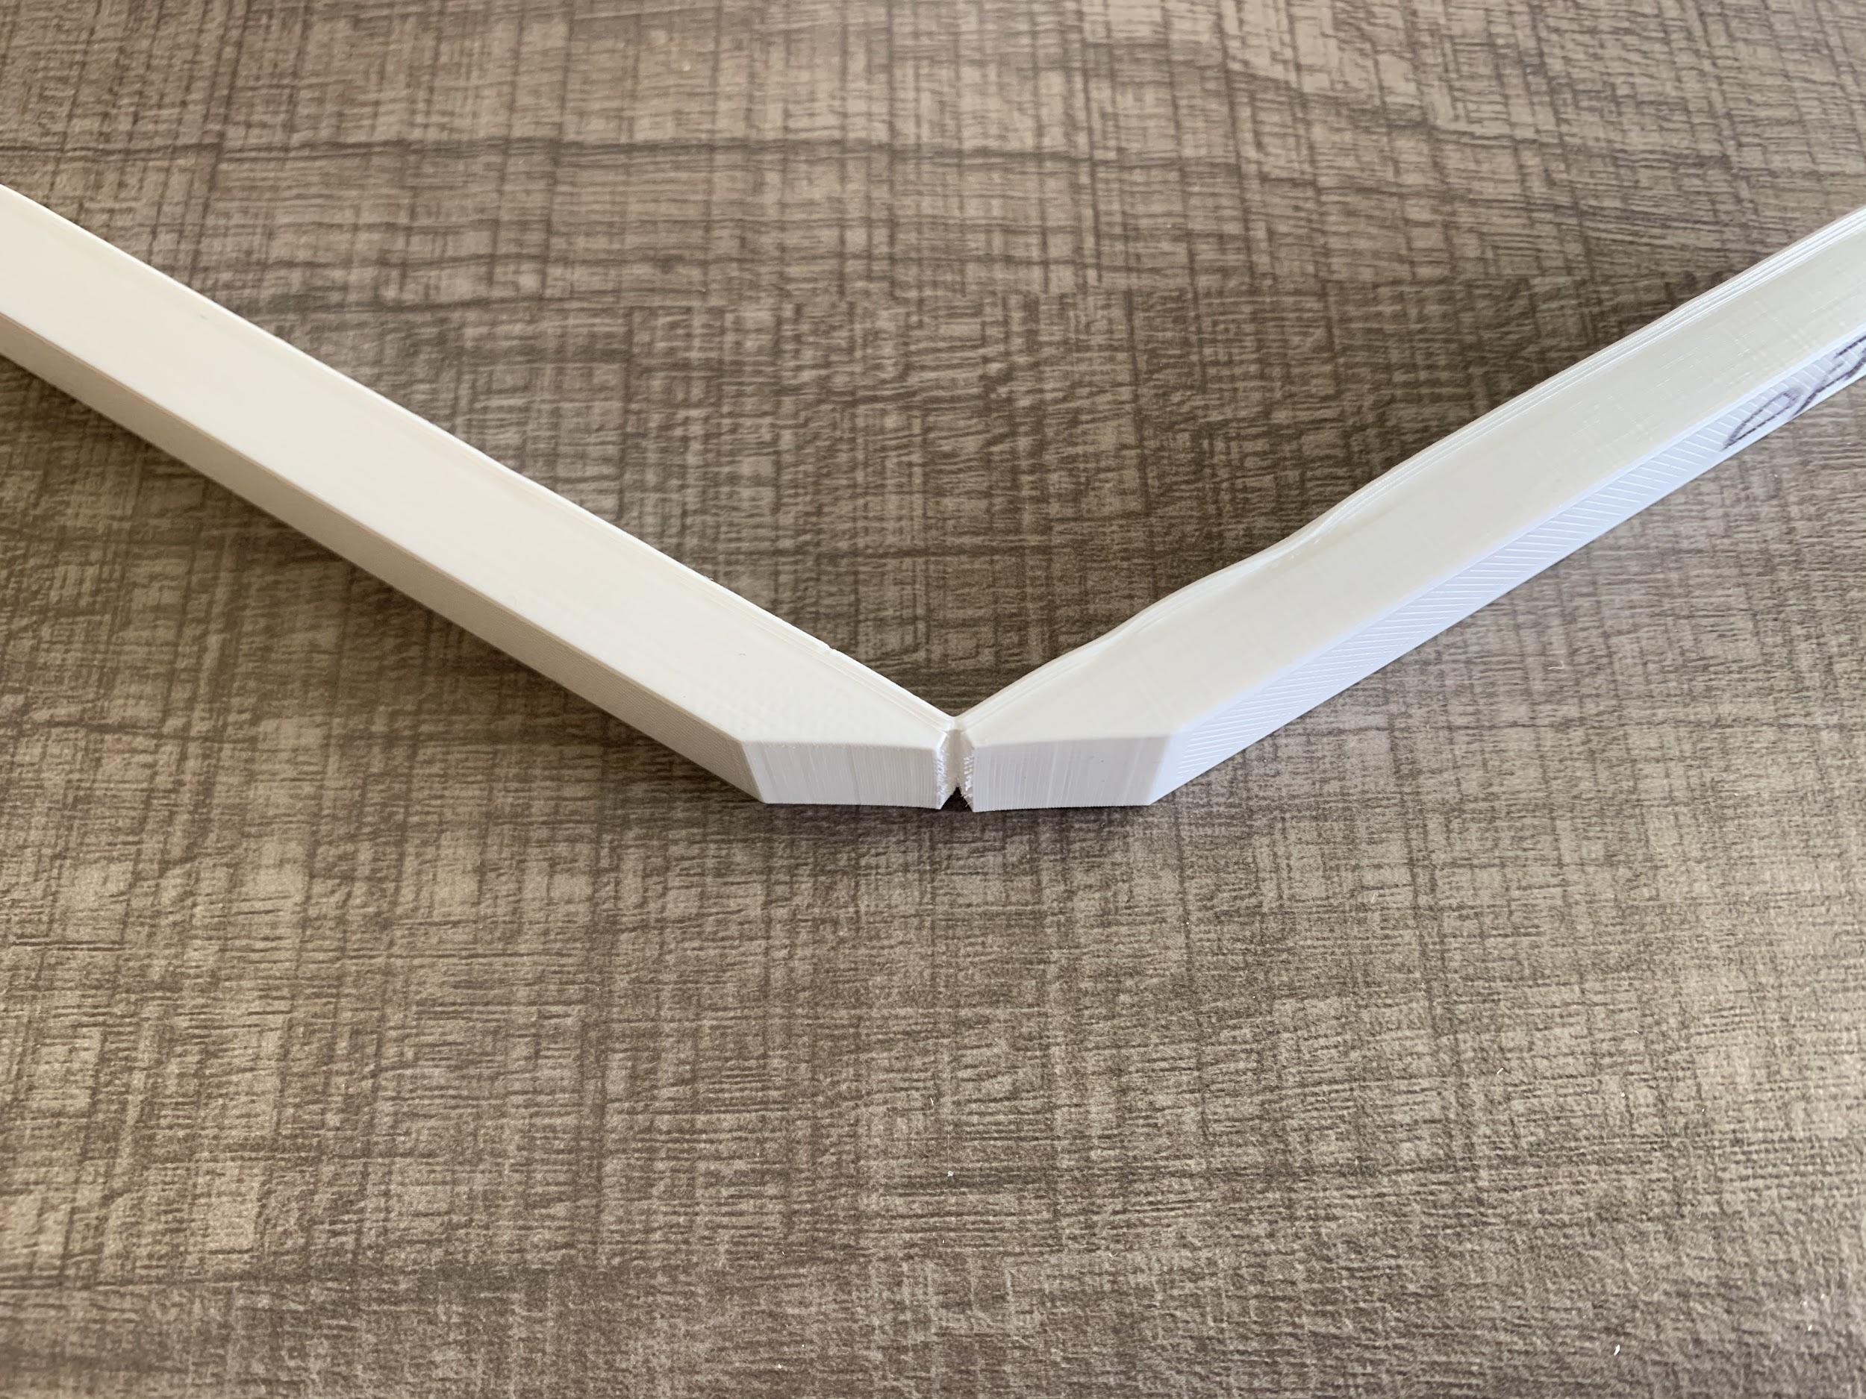
* Piece 1: Top layer (above damage) separated on one side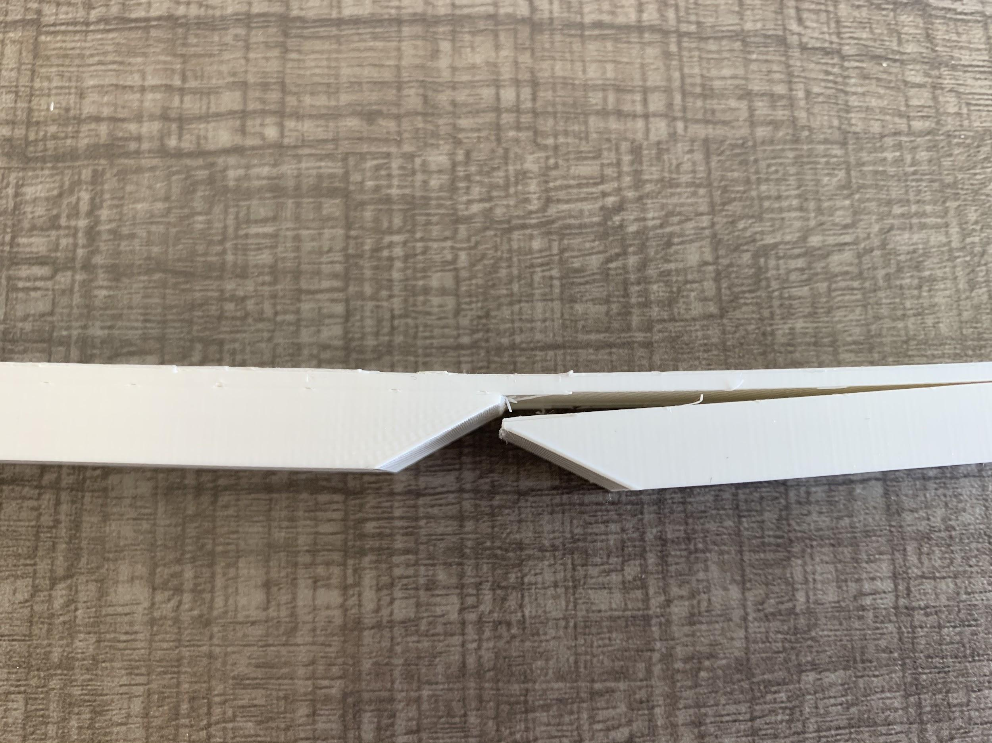

Repair Infill 1 (Tension):

* Same break in every piece - repair snapped off one end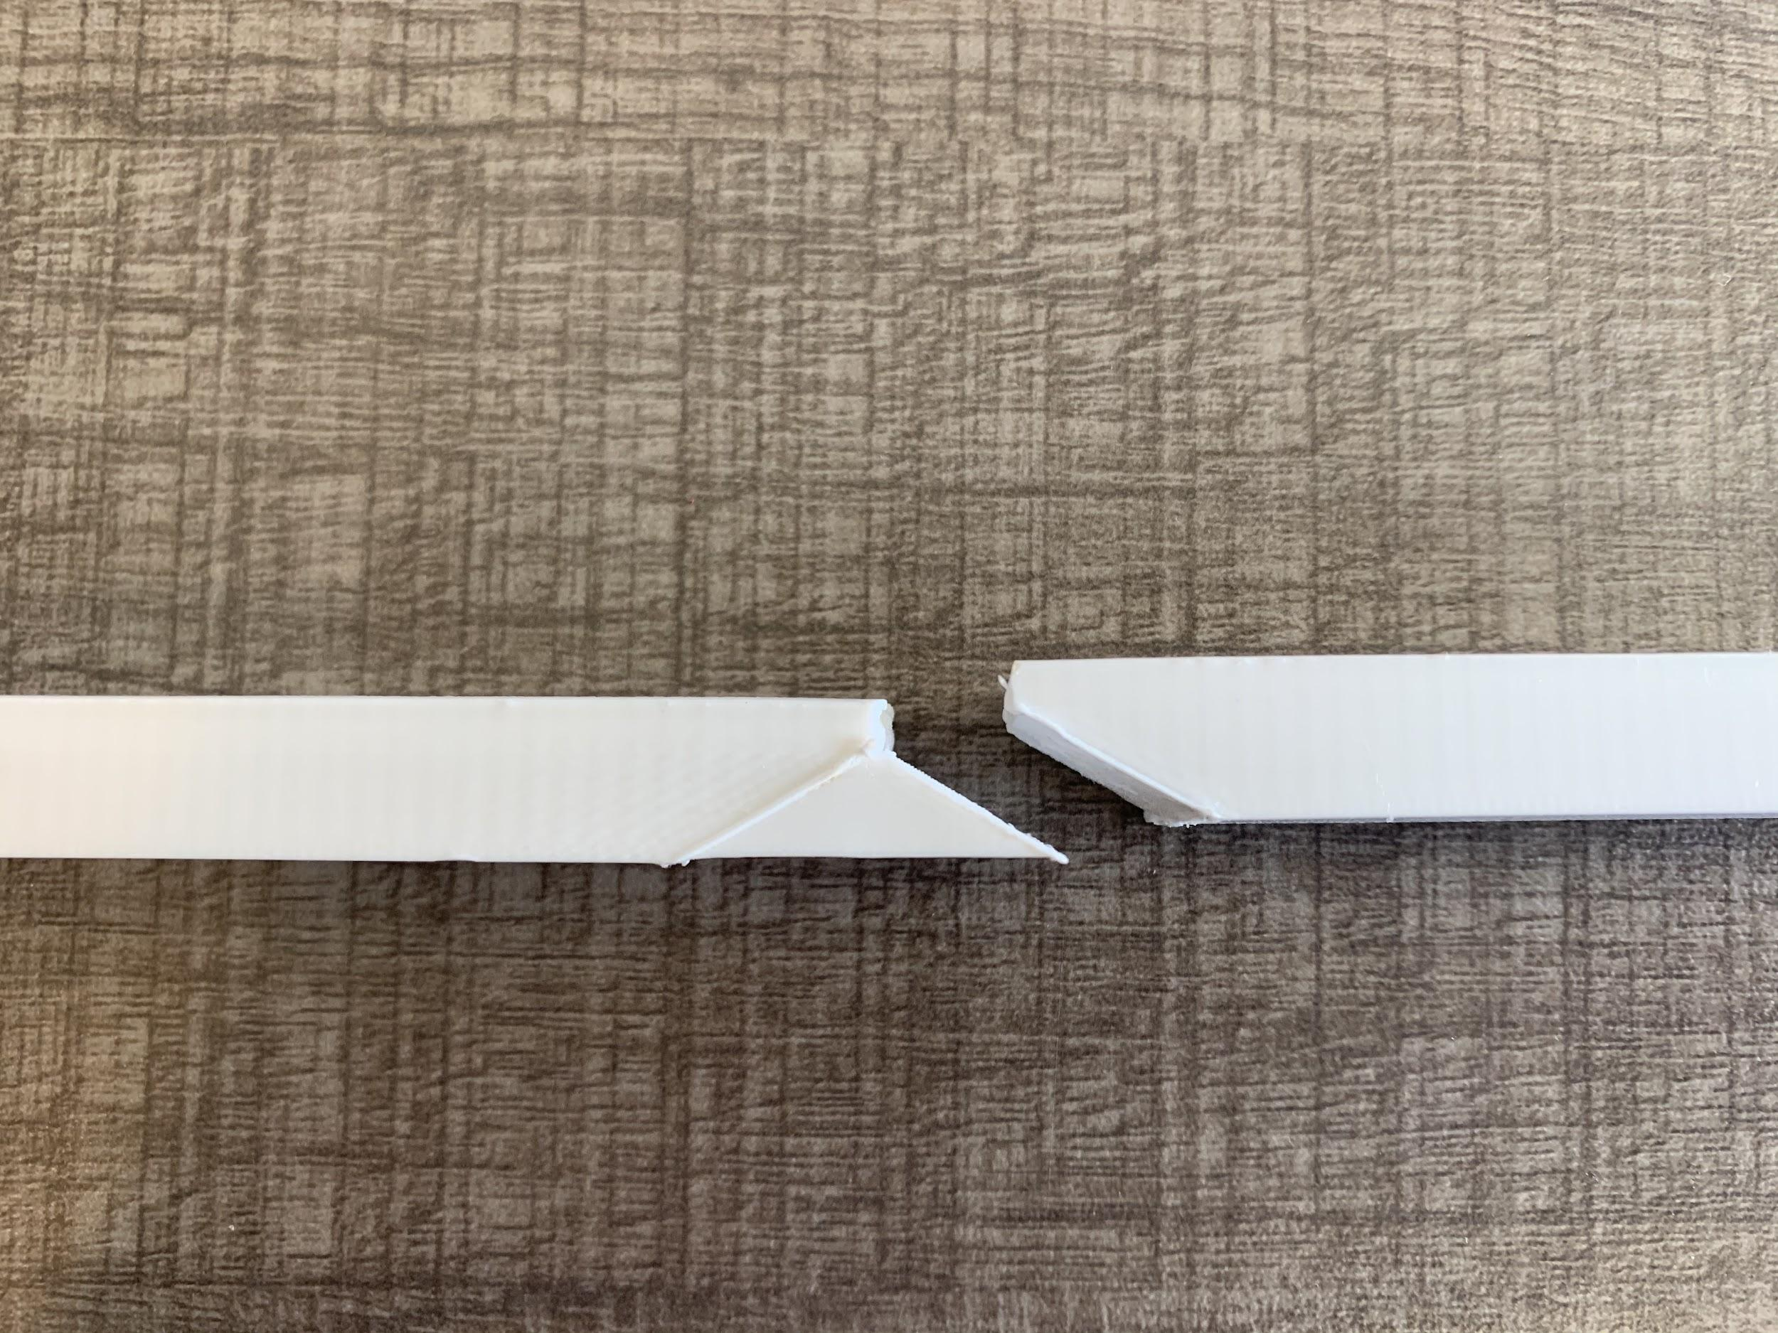

Repair Infill .8:

* All broke slightly off-center; vertical break from top down to repair; repair separated rest of the way down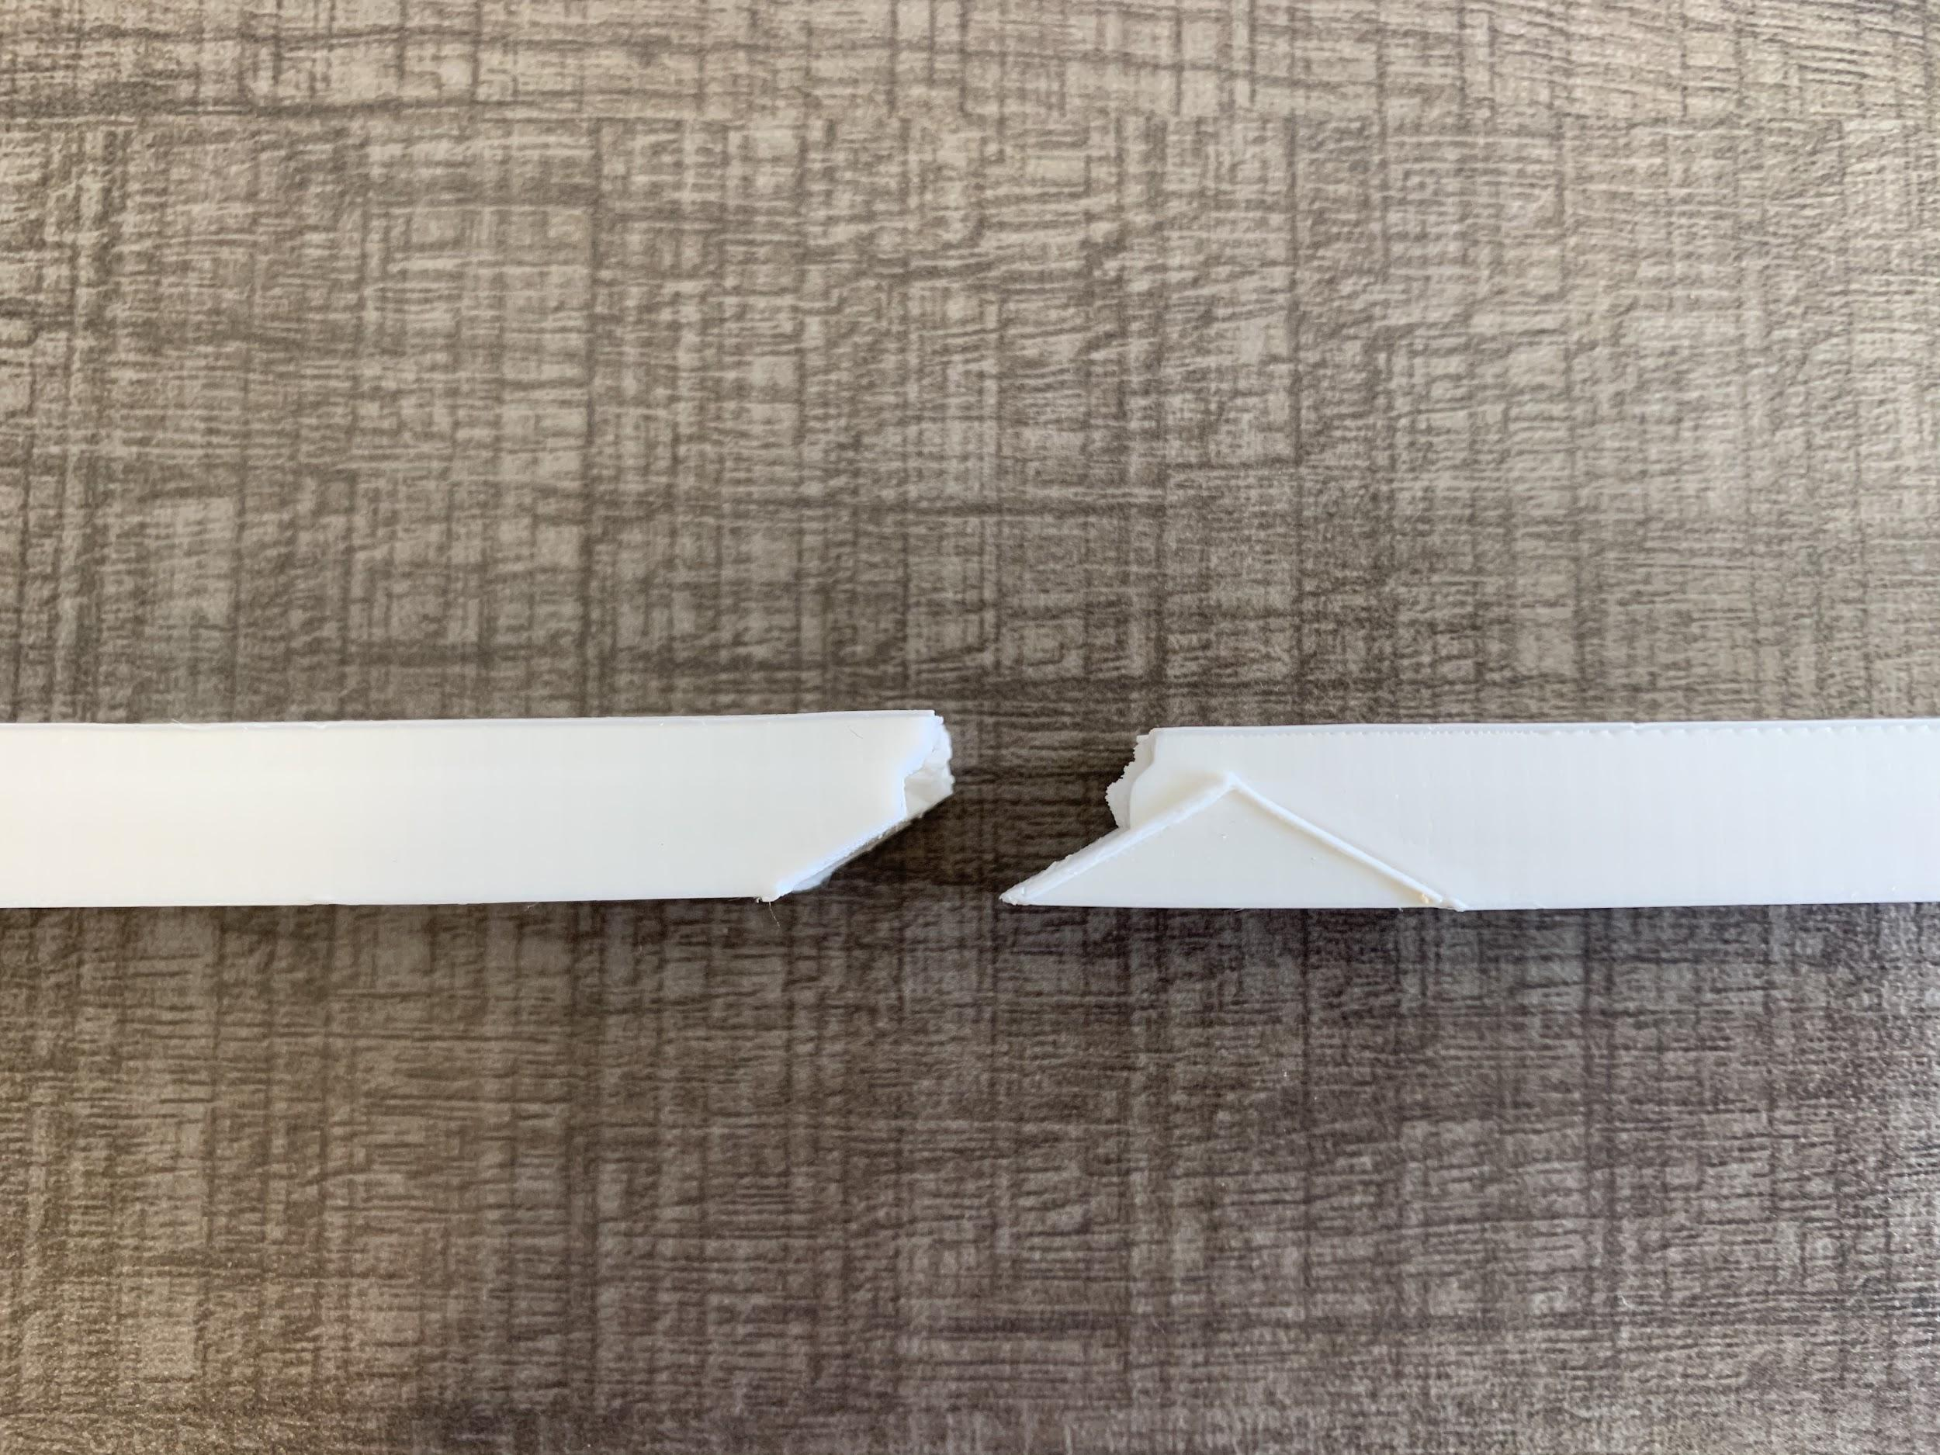

Repair Infill .6:

* Sudden break; repair snapped off one side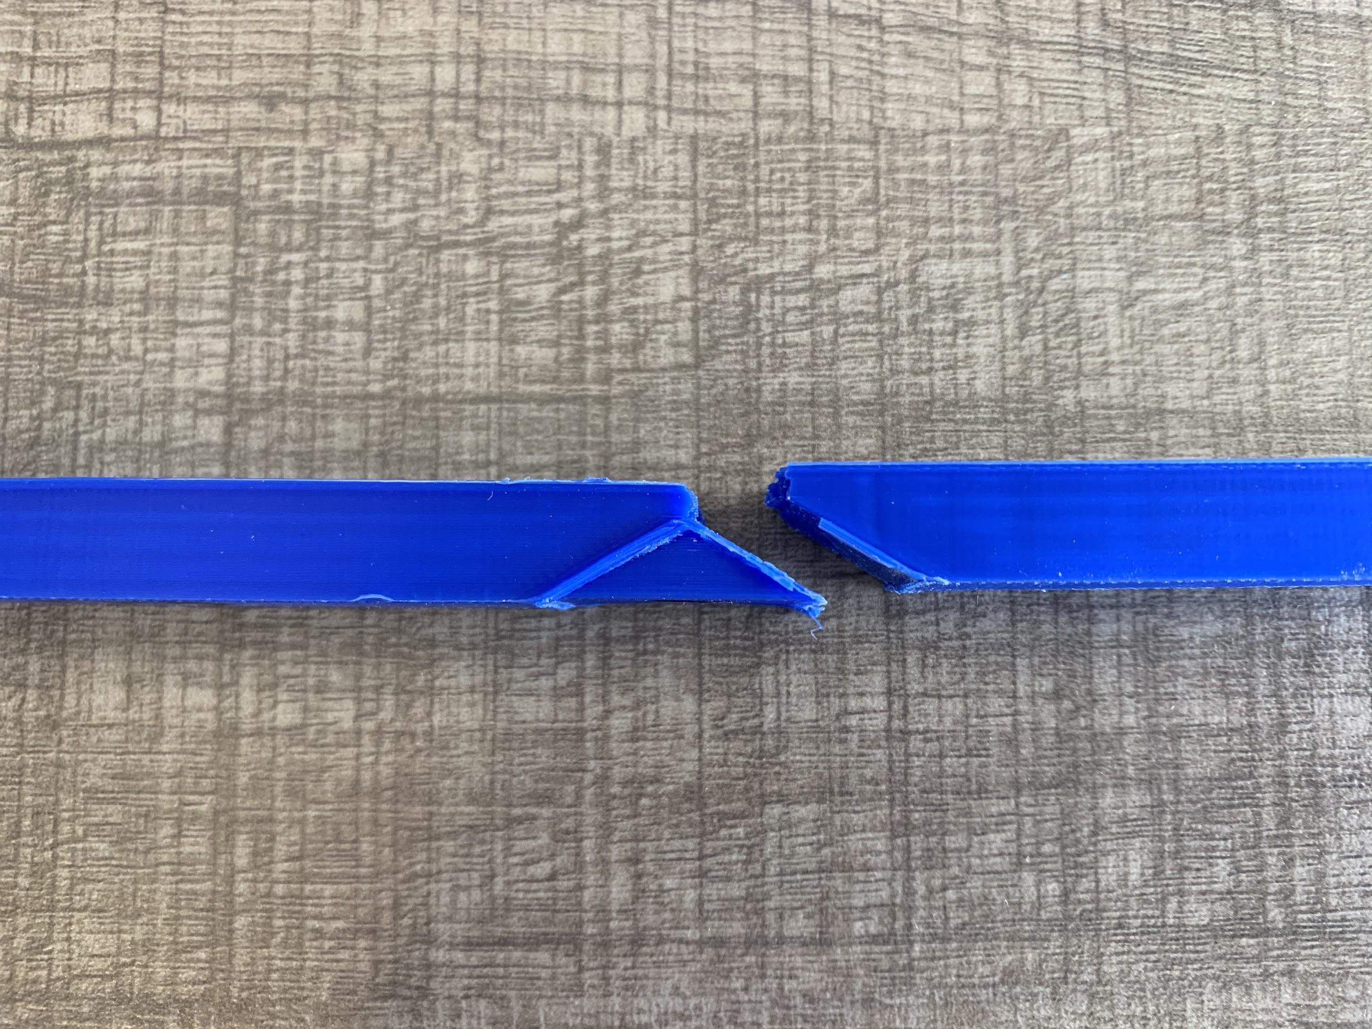

Repair Infill .4:

* Vertical break at midpoint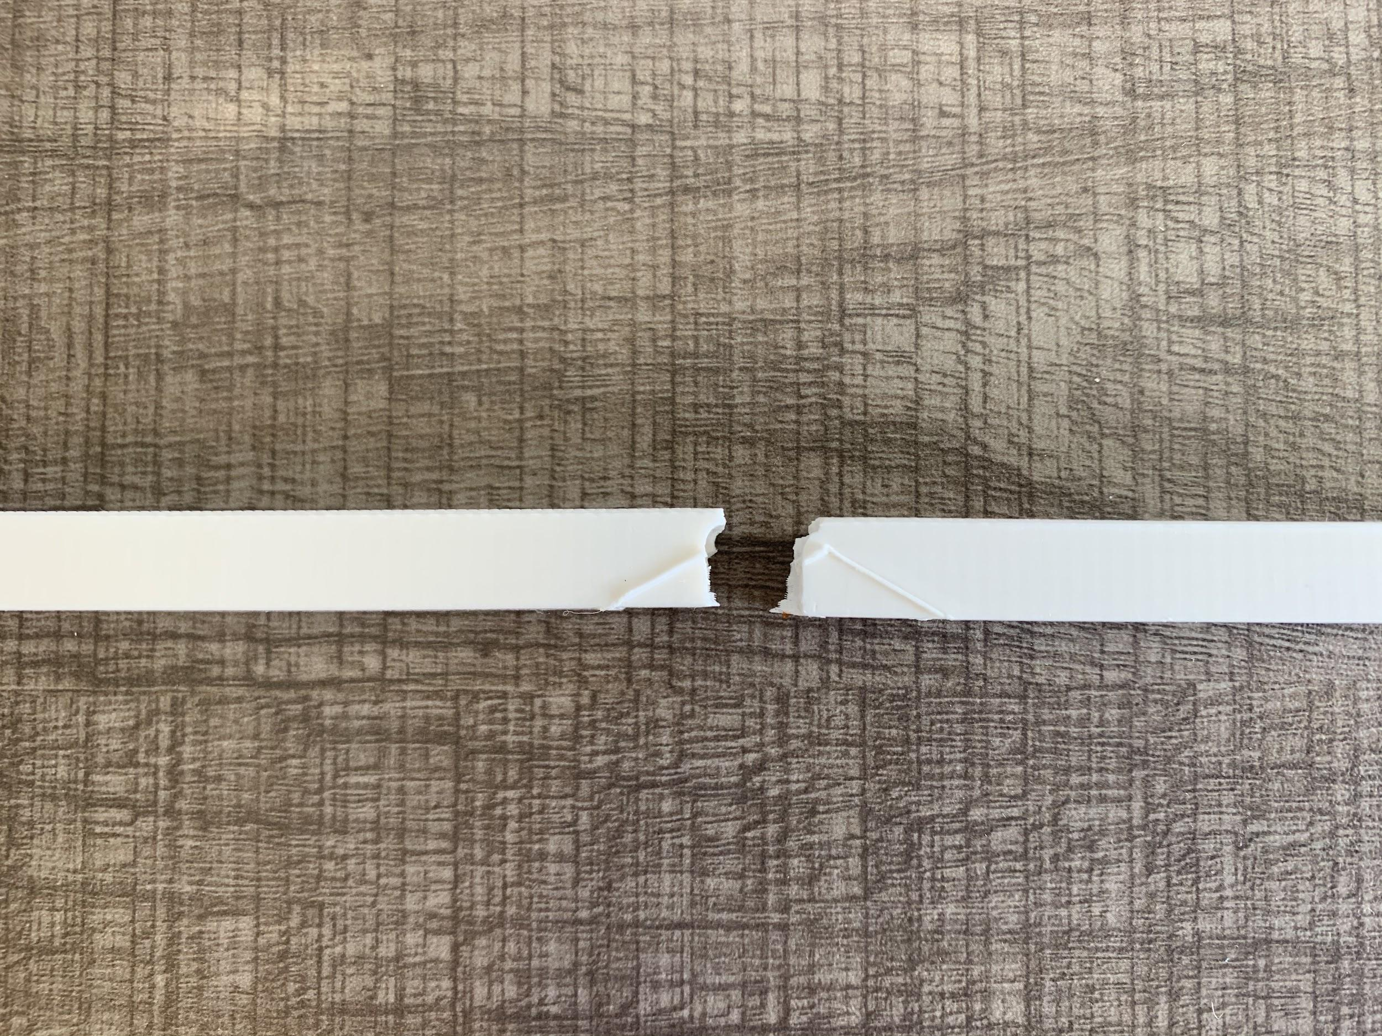

Repair Infill .2:

* Pieces 1 and 5: Gradually tore apart at middle; no full break; similar behavior to damaged pieces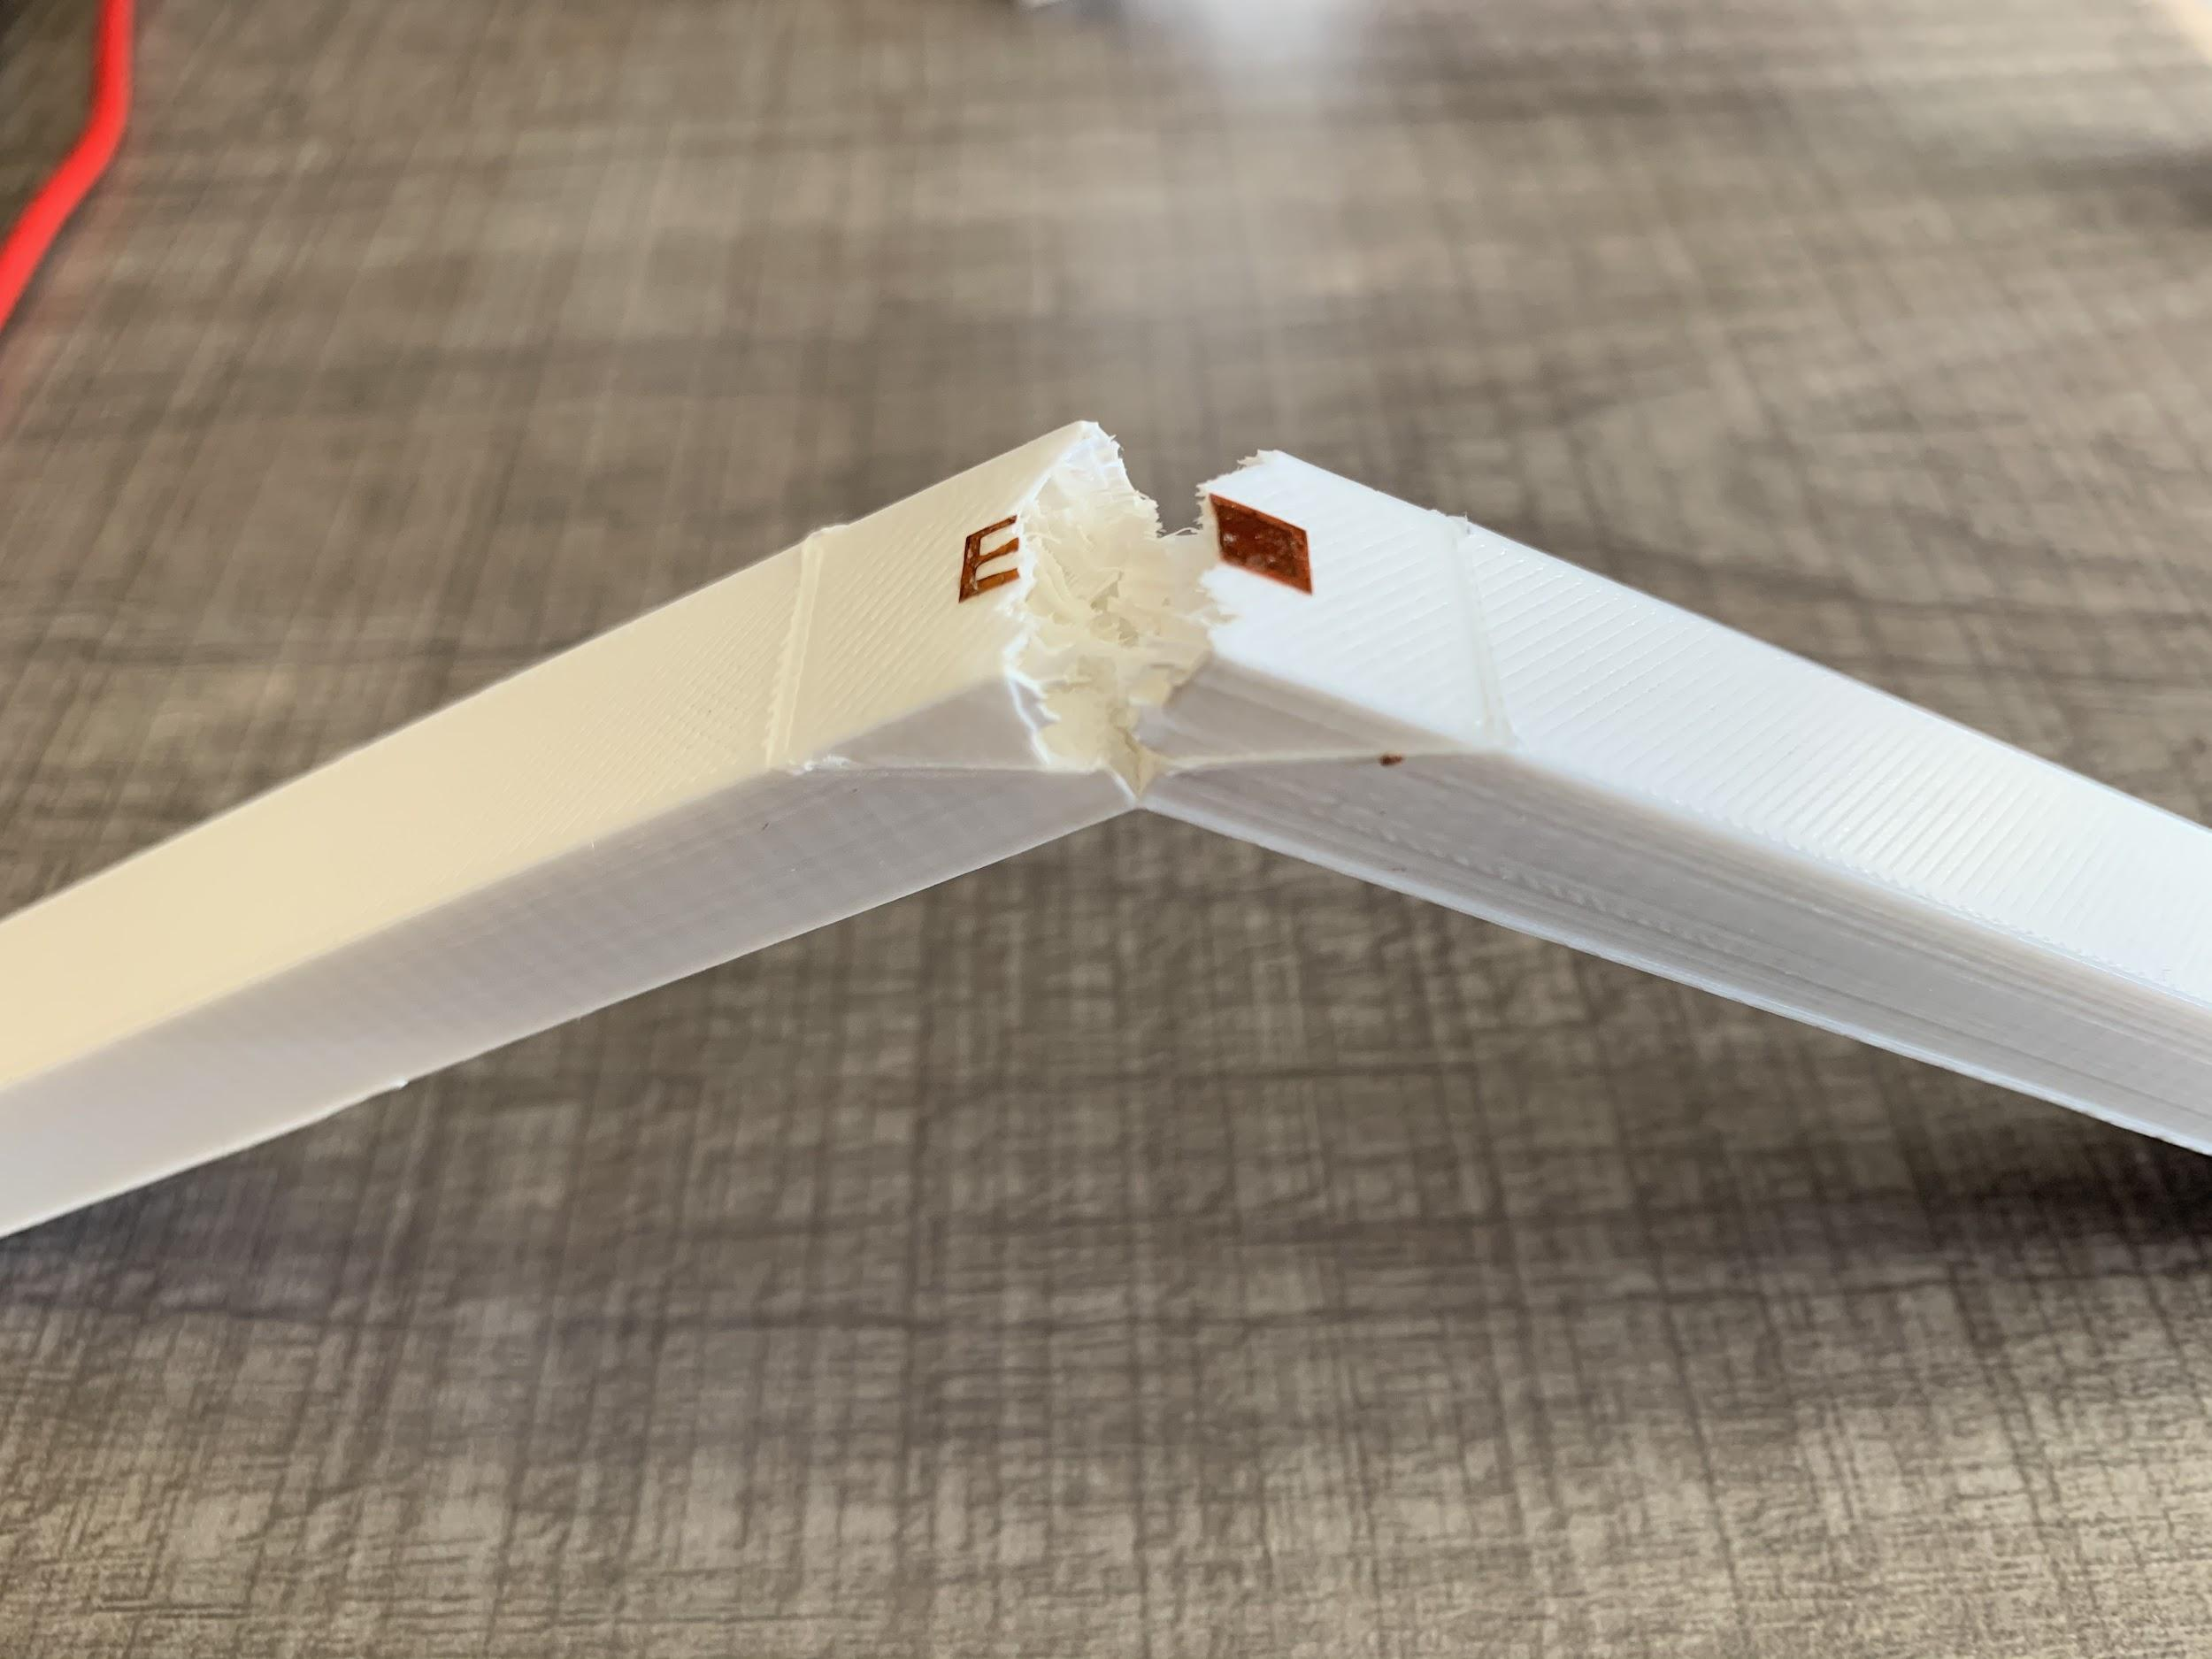
* Pieces 2-4: Sudden break; flexural failure at midpoint; heard some loud cracking/tearing noises prior to actual break (repair failed first?)